Optimisation

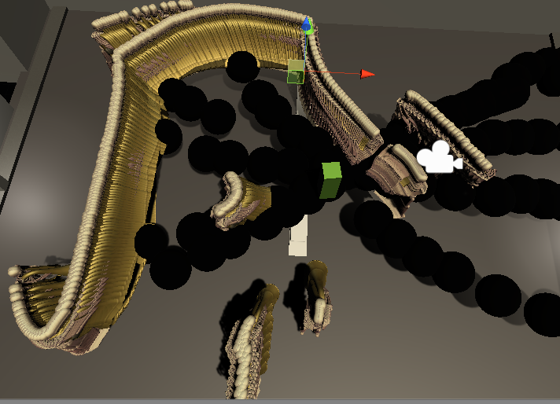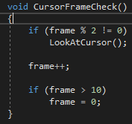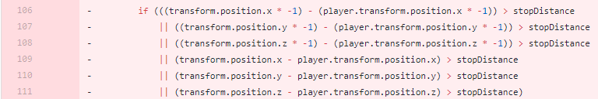

Stress testing “Tuboners”

The player looks directly at the mouse but this uses an expensive raycast. I mitigated this by instead making it run every other frame

Experimentation gifs can be found in the same folder as this documentation. They are gifs of failed shaders that were by-products of the creation process. BurnClip was made this way!